**Unit 1 Homework:** Kickstart My Chart

1. Given the provided data, what are three conclusions we can draw about Kickstarter campaigns?

When looking through the data, one can notice that the successful Kickstarter campaigns in the data set are related to the arts, including Film & Video, Music, and Theater. The categories of Food and Publishing have the highest number of failing or being canceled. The sub-category Food Trucks and restaurants have the highest failing rate.

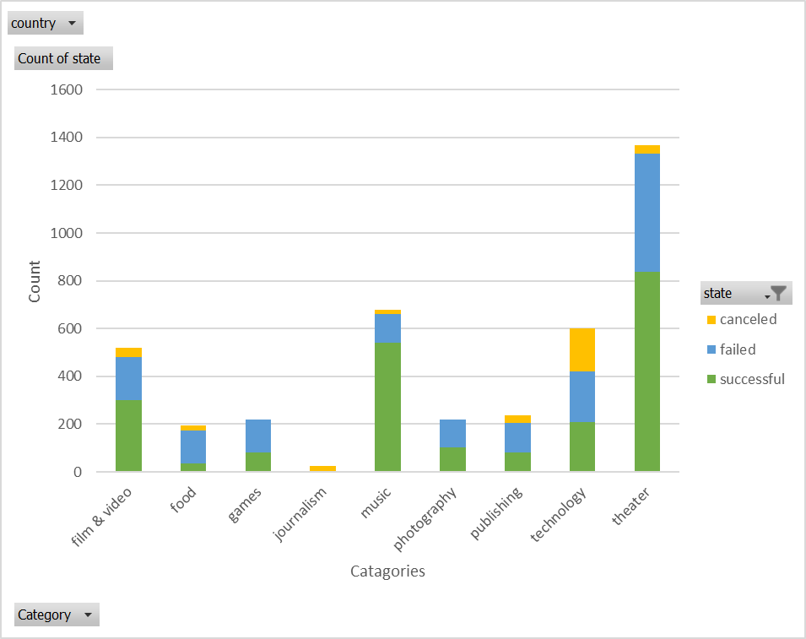

The Music campaigns have the highest success rate of 4.5. Followed by Theater with a rate of 1.7 and Film &Video with a rate of 1.66. Music successful campaigns sub-categories can be seen in Rock by 100% success followed by Indie Rock by 70%. In average, 10 Music campaigns fail every month. The successful months are the spring months and the least successful months are during the late winter months. One could assume that the late months of the year are low as a result of citizens being preoccupied with the holidays.

Campaigns that utilized the Spotlight option had successful campaigns in the dataset. This option in Kickstarter, allows the campaign creators to make a permanent page to stay up-to-date and assists with formulating foot-traffic to the site.

1. What are some limitations of this dataset?

Potential limitations of the data set can be:

* The accessibility or knowledge of the kickstart program from the launchers.
* The marketing ability and reaching out methods for the campaign to be spread to and raise money.
* The size and location of campaigns targeting region. For example, if the marketing means are targeting all or only the local, state, country, worldwide population.
* In the data set some campaigns claimed to have a goal of one dollar, allowing them to claim the successful state almost immediately. A realistic goal to a functional realistic budget should be to determine and noted for the campaign to be determine successful.
* The time when the campaign is launched, and the duration of the campaign is a limiting factor for it prevents potential fundraising.
* One of the issues of the dataset is that it includes only a few months of 2009 and 2017. The 2009 data is limiting for it was when Kickstarter was founded. This can be an issue for it small campaign themes it can push the mean rate of success or failure to a direction.

1. What are some other possible tables and/or graphs that we could create?

* Pivot Table comparing- Sub-categories vs time (years/months) per country

Will have a more detailed description what specific campaigns are formed in a country and how likely they are to succeed in a certain period of the year.

* Create a pivot table and scattered plot chart to identify the relationship of the “Staff Pick” to the Spotlight option by category.